WL PTA Meeting Minutes

Monday, February 12, 2017

WELCOME

SCA UPDATE
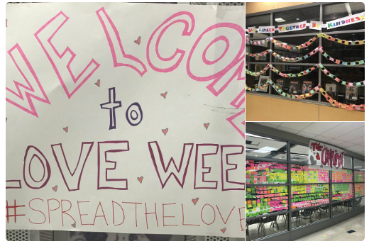
- Love Week, a student-led initiative to promote acts of kindness is under way. Program elements included chalk drawings on the Stafford Street bridge, a Compliment Wall in front of Cafeteria and other expressions of kindness and compassion throughout the school.
- The Blood Drive will be March 22. Older students are allowed to give. Parents are invited to come in and donate too! Last year, the SGA-sponsored drive got 100+ people to donate. Each donation can touch up to three people’s lives. It will be publicized in regular channels.
- Elections for next year’s SGA officers will happen in May. The week of May 7, packets will be available for interested candidates. Student elections will be held week of May 21.

STUDENT PRESENTATION: MEMBERS OF THE ASANTE MARIAMU CLUB

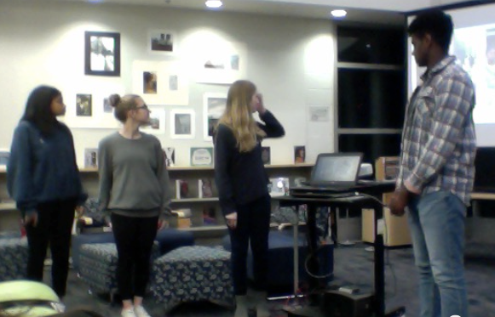
Asante Mariamu is an international non-profit to help people with albinism in Uganda and Tanzania. In parts of the world, albinism is highly stigmatized, and people affected by it have difficulty accessing resources and education. The focus of the club at W-L is to raise money to sponsor a scholarship for a student affected by albinism in one of these countries. The club also uses money it raises to support people with albinism in these countries in other ways, such as sending sun glasses. At the Holiday Bazaar, the club raised $1K, and that went directly towards a student scholarship. Members of the club presented at the PTA meeting, giving an overview of their activities, talking about how they got involved, and answered parents’ questions. The students also thanked the PTA for the grant they received to support their work. The students also invited parents and members of the community to support their work by participating in a “Cycle for Students” event which will be hosted on March 18 at 2 p.m. at CycleBar at 3400 Columbia Pike, 22205. Support a great cause while you exercise. There will be a raffle, and pie from Livin’ the Pie Life. $30 includes the ride, pie and a ticket to the raffle. Go to http://bit.ly/2lsdCY2 to register. Another big initiative for parents to get involved: the club is collecting old smartphones that still have working cameras. These are re-used in Uganda and Tanzania to help provide medical care to people with albinism by helping doctors remotely care for people affected by the condition. More info on how to donate old smartphones will be communicated via the PTA newsletter.

PRESENTATION ON SOCIAL MEDIA: OPPORTUNITIES AND THREATS — BY ASST. PRINCIPAL CLAIRE PETERS AND INSTRUCTIONAL TECHNOLOGY SPECIALIST CRAIG SPRAGGINS

- The one constant is that the landscape is continually changing; social media platforms continue to emerge. There isn’t just one “place’ where kids hang out online.
- Presentation is going to focus on the platform where we see the most traction with our students: Snapchat, Instagram, Twitter, Reddit.
- Snapchat: an app with which you can send photos or video. The image/video can be viewed for 10 seconds max and then it “disappears,” in that the person receiving the snap cannot see it again. There's one exception: you can replay one image/video once. It is possible to screen shot an image that is sent to you via Snapchat. When someone does this, the person who sent the image is alerted that it was captured via screenshot. Snapchat also features filters, which allows you to alter images in funny/cartoonish ways. With filters, some images may be hard to identify the people in it.
- Instagram: a photo sharing site that seems to be more popular with our students than Facebook, Photos can go with captions, comments. There are privacy settings that allow you to dial access to who can see what you post — from private to public.
- Twitter: Short text messages (140 characters or less); images, links to sites, and video can also be embedded. This platform seems to be mostly for staying updated on developments/getting information. Your activity on twitter (what you like, re-tweet, etc.) will show up in feeds.
- Reddit: Discussion forums - you don’t have to have an account to read the forums but if you’d like to contribute to a discussion or start a new one, you need an identity. It’s a very open forum.

Our message to kids:
- What you post online can be permanent.
- You can lose control of what you post and/or comment; be aware of the risks
- Know your privacy settings, make sure you read the privacy policy and terms of agreement
- It can be addicting, distracting and time consuming; balance and time management can become issues.
- Your social media presence will follow you and surface in sometimes unexpected ways. For example, when President Obama came to visit W-L some years ago, he met with a group of students. The Secret Service asked for the names of the students and their public social media presence was reviewed as part of the vetting process that happened in advance of the President’s visit. Be aware that what you post publicly can be reviewed by people that may not have been your intended audience. And that audit can happen years after the initial post was made.

PRINCIPAL’S REPORT AND UPDATE FROM COUNSELING

- Activities Fair (2/7): As we grow as a high school, there are relatively fewer opportunities to participate in some sports. (e.g. as student population rises, basketball team can still only field five players on the court at a time). While each sport seasons always has at least one “no-cut” sport, where any student would be welcome to participate, the emphasis on exposing students to what clubs/activities are available is especially important as our population grows. And so we continue to host Activities Fairs throughout the year to increase awareness and encourage kids to get involved. There are more than 100 active clubs at W-L. Earlier in the year, Activities Fairs were hosted (including one targeting incoming 9th graders at Freshman Orientation). By bringing the Activities Fair back in February, we hope to connive to surface opportunities for kids to get involved. (You can join a club anytime, not just at the beginning of the year). The Fair was hosted during all lunches, where clubs set up tables and engaged with prospective members.
- Senior Experience Orientation took place on 2/8. Our Seniors got a feel for the process and an overview of the new dates that are coming up.
- Electives Fair is on 2/15; we conduct that this time of year because we’re going through the scheduling process. We want to make sure students know what electives are out there. (Foreign language, Arts, the Theater, etc.) The teachers come out in full force because they want to grow their program.
- School Musical “Pippin” was a great success. Congrats to all that participated.
- Music concerts are coming up. We have the Band Concert on 2/16 at 7 pm and the Orchestra concert on 2/23 at 7 pm.
- Spring Sports start on 2/20. We’ll have Baseball, Softball, Lacross, Tennis, Soccer, Crew (no cut), and Outdoor Track (no cut).
- The Black History Month Assembly will be on 2/24 during 2nd period. Parents are welcome to come. Because of the size of the school population, it’s a rotating assembly schedule to give all 2,000 students the opportunity to enjoy the program.
- In early March (3/9 and 3/10), the Administrators and Counseling staff will go into Freshmen PE classes to play volleyball with the 9th graders. The purpose of this is to get to know them better and have the chance to interact with them. This initiative also happened in the Fall. The Spring “Volleyball with Freshmen” gets to the students who started the school year in Health.
- Spring Break will be 4/10-4/14 and the Monday of the following week (4/17) is a Teacher Workday. (no school for students)
- The Whole General program is an initiative that was started last year. It includes grade-level short assemblies to talk to the kids about different topics that we know are important:
  - 9th Grade: Relationships - The Freshmen are all arriving from the middle schools and need to make new relationships at W-L. We talk to kids about making healthy relationships, at school and beyond.
  - 10th Grade: Balance: This is where we see the AP/IB pressure starting to mount. We talk to kids about how to maintain balance and manage stress.
  - 11th Grade: Good Choices. Kids are looking into colleges, they’re getting Driver’s Licenses. We have discussions about good choices across a whole spectrum of areas where kids need to navigate making good choices, including alcohol, drugs, drinking and driving, and more.
  - 12th Grade: Responsibility: They’re about to head out on their own; most of them are headed to college. Once you’re away from mom and dad, how you are responsible and can make good decisions. We talk to them about responsibility as they enter the next chapters of their lives.
- Scheduling: we’re in the thick of scheduling season. We hosted Scheduling Night for parents and had packed houses. We’ve been talking to your kids about their course selections for next year and ask you to too. Counselors have gone into classrooms and met with all the kids. This year we continued our move towards paperless (in large part in response to request we were getting from the students as expressed by the Student Advisory Councils at both the school level and at the School Board level). The course catalogue is online. Schedule Request Forms are due by the 23rd. If your kids have questions or need help, have them go in to talk to the counselors. It’s OK to just drop by, or kids can also schedule appointments.
- Once all the course requests come in, the master schedule gets created to reflect that. By May, teachers know what they’ll be teaching and we’re clearing up for conflicts. We make staffing decisions for next year based on what we’re seeing now.
- Final notes: Kindness week was last week, contributing to the love-fest culture we’re cultivating here. :) For 9th Graders our emphasis is on building empathy. Last week was National School Counseling Week.

NOMINATING COMMITTEE

- The members of the Nominating Committee were appointed by unanimous vote.
- Karen Hancock, Latonya McGowan, and Tatjana Curcic will lead the effort to recruit leaders for next year.
- There is a timeline for this process in the bylaws.
- Calls for nominations will immediately go out.

PTA PRESIDENT’S REPORT

- We had several students place in the regional PTA Reflections.
- Dr. Robertson shared he had the pleasure of notifying the kids.
- We had one student win the region, she is going on to the state-level competition. Very exciting!

TREASURER’S REPORT

- For income, our year-end goal is to have raised $28,000; we’re at $20K now.
- We’re not collecting many more dues. If we’re going to make up the rest, we need to do so through the grocery card and the plant sale.
- Most of our big-ticket items have already been spent.
- We had budgeted to draw down and we’re tracking to that.
- We’re eagerly looking for our next Treasurer. Blurbs have gone out in the PTA Newsletter. Pls contact Lee Dioso if you are interested.

NEXT MEETINGS

- March 13: Alcohol and Drugs
- April 3: TBD
- May 8: What to Expect the First Year: Outreach to the parents of 9th graders
- June 5: End-of-Year Picnic

