WL PTA Meeting Minutes

Monday, May 8, 2017

WELCOME

Welcome Middle School parents who are joining our PTA meeting for the first time as their family transitions to W-L. Welcome!!

RECOGNIZING STATE CHAMPIONS

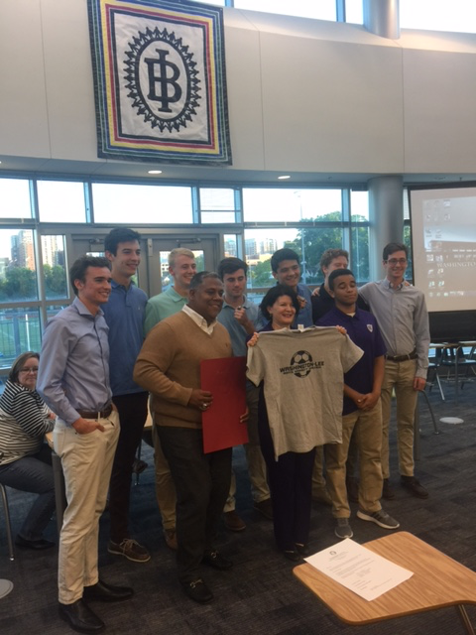
Senator Barbara Favola kicks off the meeting, presenting the 2015-16 Boys Soccer Team with a declaration from the Virginia State Assembly recognizing the Boy Virginia State congratulating the state championship.
CAPACITY

John Peck of the Facilities Advisory Community from the School Board and he is involved int he discussion adding high school seats. Quick update:
- The School Board will vote the first week of June on where to put the additional 1300 seats that APS needs to serve the additional students coming up through the system. The three options are Ed Center, Career Center and Kenmore Middle School.
- Another option is being developed by Staff would bring about half of the 1300 number to W-L. This would be on the Ed Center site and could be a scenario
- There are many groups of parents who have a vision for what they would like to see.
- A High School at the Ed Center site that could be completely separate for W-L, which is another scenario.
- Email APS staff through the Engage email address to share any feedback. Engage@apsva.us
- Also feel free to contact APS School Board Members.
- Many of the most involved parents are in Elementary Schools
- On the FAC they studied successful high schools of all sizes across the country.
- W-L used to be a big 3000+ person school.
- 2022 would be the “move-in” date
- Be aware of what’s going on.
- If you have questions for John Peck email wlpta@hotmail.com and those q’s will be forwarded to him to get those questions answered.

RISING 9TH GRADERS - TRANSITION TO HIGH SCHOOL

Jeana Norton presented “What to expect for 9th Grade and How to be Successful - a presentation on the Small Learning Community program
- SLCs are three core teachers (World History, Biology and English) teach the same group of kids. A Special Ed teacher is also assigned to each group. They meet regularly to discuss the progress of students to try to ensure they're collaboration ot help the 9th graders make a successful transition.
- Next year there will be 4 SLCs. Each SLC has 150 students.
- Right before school starts there is a summer orientation. It’s Friday, August 25 — 8:15-10:30. Teachers will be here, there will be panels with upperclassmen. Freshmen will be able to purchase their locks and pay freshman class dues.
- The Connect Mentors are 11th and 12th graders who help the students transition into the high school. There will be about 90 connect mentor. Three are assigned to each Freshmen GP class. They go in and do activities, team building throughout the year. These are monthly sessions and in addition to that, each mentor goes into the GP on their own and works with a smaller group to make sure they are getting involved.
- On the first day of school, the connect mentors cheer for the Freshmen as they enter the building.
- Tips on making 9th grade successful:
  - Get acquainted with the Block Schedule
  - Organize the night before to make sure you have the correct W or L day materials
  - Use the student planner that they are given by the school. Teachers also allow students to use their phones to record homework assignments
  - Do the homework on the day it’s assigned. Most teachers have a webpage/blackboard where they can go to get synched up on assignments
  - High Schoolers will get bigger assignments. Intensified courses will have increased workloads. Plan ahead.
  - Get help early. Zero Period sessions are always available for Math and Science. See teachers during Generals Period. There are Lunch Labs for English, Math, Science and Social Studies. Saturday School. Seek out help. Parent q: do kids email teachers asking for help. Yes! email addresses are on the website.
  - Check ParentVue and have students check StudentVue.
  - Empower your child to start advocating for themselves.
  - Get involved - there are more than 100 clubs at WL and sports for every season
  - Have balance! Get enough sleep, eat well; be physically active, have fun!
- For families that will e out of town during Freshmen Orientation, there are opportunities throughout the
- Dr. Robertson and Ms. Calloway (Director of Student Activities) meet with every freshmen in Dr. Robertson’s office in groups of 10 to encourage them to get involved. They get individualized attention in addition as well.

PRINCIPALS REPORT

- DC Field Trip with HILT Students - PTA Grant on May 4. Each administrator takes a group of 10 HILT-A kids at the beginning of the year and follows those kids through the year. Dr. Robertson and Ms. Calloway went on a tour of DC. Only two students of the group of 20 had previously went into the city. It was great experience.
- SOLs - computers charged. Schedule Posted on the Website. Reminder: arrive with a fully charged computer. Bring charger!
- Capital Bike Share has been installed in front of the bike racks by the front door of the building. Students can get a membership and ride the bike. Q from parent: What ads will go into the panel. Dr. Robertson didn’t have that info; will follow up.
- SCA Olympics: this was on April 27 on the football field. They did games/Olympics/pep rally. It was very well organized this year.
- Senior Calendar was mailed home to all Senior families and it’s also on the website. Gives dates/times for logistics, graduation.
- Senior Classroom Visits. Assistant Principals have been going into Senior English classes and talking about the importance of a strong finish. We want to encourage students to be smart, don’t play any pranks, etc.
- Senior Experience (5/22)
- Senior Experience Application Deadline (5/15) We usually have 98% participation in this. If your'e that parent of a senior and you haven’t heard about it, ask your student.
- PTA Luncheon (4/7) Thank you. It was wonderful. The teachers appreciated it so much!
- Hispanic Parent Lunch (5/19) This is also an event coming up and our teachers are looking forward to it!
- Prom (5/19) We’ll be communicating more with seniors. We send a letter at the last minute. Please know what your Senior is doing. Across the country, a lot of accidents occur and we want to do everything we can to keep our kids safe.
- Memorial Day Holiday (5/29) Reminder: no school.
- Spring Sports Banquet (6/7 at 7 pm) to celebrate students participating in spring sports. It’s a pot luck
- Graduation at DAR (6/21 at 10 am) Five tickets per senior. For those who need more, there is a lottery.

COUNSELING UPDATE

- Scheduling. Expect to see preliminary schedules come out in June. Check these and make sure they look right and let us know if there are issue. This will also give you info for any links to get info about summer assignments associated with coursework
- Stress Less, Laugh More: This was a week-long program to encourage students to have balance. There were different activities during lunches (Zumba)
- Freshmen Tour Dates (7/19, 8/2, 8/16 at 2 pm) These are the dates where Freshmen who won’t be at Orientation can come. It's a great way to have questions answered as you see the building. Kids and parents are welcome. It will give you a sense for what the school will look like. Summer School is going on at W-L this summer.
- Freshmen Orientation (8/25)

PTA OFFICERS FOR 2017-18 SCHOOL YEAR

- 1st VP Ted Black
- 2nd VP Deborah Wooldridge
- Treasurer Scott Burka
- Secretary Tina Evans

These individuals were voted on by voice vote unanimously.

Zelmira McCan volunteered to serve as President Elect from the floor. She made a short impromptu presentation about her experience

She was elected by unanimous voice vote.

TREASURER’S REPORT

We’re going to be very close to our forecasts for the year. Our actual totals are coming in very close to what we expected for both income and spend. The new PTA Exec Board will meet over the summer to develop a budget for next year.

PRESIDENT’S REPORT

Thank you! We want the PTA to finish the year strong. The Senior Picnic is advertising for volunteers and donations. The Senior Boat Party will soon be doing the same.

