WASHINGTON-LEE HIGH SCHOOL
Chinese IB binitio
Teacher: Mrs Luu
Room: 3016
Extra help: General’s period
Janet.luu@apsva.us

Arlington Public Schools World Languages & IB Mission:
To develop functional oral and written communication skills in the target language and an understanding of other cultural perspectives and practices. To develop inquiring, knowledge through intercultural understanding and respect.
Nature of the Language ab initio: Three areas of study—language, texts and themes—provide the basis of the two-year language ab initio course. These three fundamental areas are interconnected and should be studied concurrently. Interactive, productive and receptive skills are developed through study in these three areas and are of equal important.
The ability to write and speak the target language effectively. Elements of language include vocabulary, grammatical structures, register, pronunciation and intonation.
The ability to comprehend straightforward written and spoken language, not only understanding the message but also its cultural and contextual connotations.
The ability to understand and respond effectively to written and spoken language. Interactive skills entail not only conveying messages and responding to written and spoken language but also demonstrating an awareness of social context.
Written and spoken material: such material will extend from everyday oral exchanges to literary texts.
There are five assessment objectives for the language ab initio course. Students will be assessed on their ability to:
1. Demonstrate awareness and understand of the intercultural elements relate
to the prescribed topics.
2. Communicate clearly and effectively in arrange of situation
3. Understand and use accurately the basic structures of the language
4. Understand and use an appropriate range of vocabulary
5. Use a register and a format that are appropriate to the situation.
Course objectives: 指定性话题
The language ab initio course is organized into three themes:
A. Individual and society
B. Leisure and work
C. Urban and rural environment

个人与社会  Individual and society | 休闲与工作Leisure and work | 城市环境与乡村环境 Urban and rural environment
日常起居 Everyday living | 就业 careers | 环境方面的顾虑 Environment
教育 Education | 娱乐 entertainment | 全球问题  Global issues
饮食 eating | 假期 holiday | 邻居neighborhood
个人详情、外貌、性格  Individual identity, personality, appearance | 媒体 media | 自然地理  Geography
身体健康 Health | 体育运动 sport | 城镇及其设施  City, town and other development
关系 relationships | 科技 technology | 天气 weather
购物 shopping | 交通 Transportation
This course comprises five topics: three from the core and two chosen from the five options. At least two aspects must be covered in each of the five topics that make up the course.
Core – There are three topics in the core
- Communication and media
- Global issues
- Social relationships
These three topics are compulsory at SL. Students are required to study at least two aspects from each core topic.
Options – Two options have been chosen from the following five options:
- Cultural diversity
- Customs and traditions
- Health (SL Yr. 2)
- Leisure (SL Yr.1)
- Science and technology
Topics/Units Outline:
Unit 1 – Social Relationships (Core) - Year 1
How people interrelate and behave – as members of a community, individually and in groups.
1. Chinese Family Structure (Bk 4, L7-9)
- Compare it with the one in your own country
2. Festival and celebrations (Bk 5,L1-3)
- Traditional festival and custom
- Traditional costume and diets (Bk4, L3)
3. Language and cultural (Bk 4/L2)
- Chinese language and cultural identity
- Relationship between friends and family members
Unit 2 – Communication and Media (Core) - Year 1
How people interact, transmit and gather data for the purposes of information and entertainment.
1. Internet and Media (Bk 5, L4)
- Mass communication
- Internet using
- The impact to modern people (Bk5, L8)
2. Advertisement
- The variety of Ad
- The impact of Ad to our life
- The language applying in Ad
Unit 3 – Leisure (Option) - Year 1
The variety of activities performed for enjoyment.
1. Daily entertainment and hobbies
- Movie (Ang Lee’s movies)
- Sports
- Music (Chinese musical instruments)
2. Travelling
- Arrange a package tour
- Introduce a city/resort
- Design a study tour brochure
Unit 4 – Global Issue (Core) - Year 2
Current matters and future scenarios that have an impact at a regional, national and/or international level, bearing in mind that they need to be addressed from the perspective of the target language’s culture(s).
1. Environment (Bk 5, L10-11)
- Global warming and its impact
- Energy, food and water
- Transportation
2. Migrants and globalization
- Studying and working abroad
3. Recycling (Bk 5, L10)
Unit 5 – Health (Option) - Year 2
Physical, mental and social well-being, as well as matters related to illnesses.
1. Diet, nutrition and traditional Chinese medicine
- Nutrition and health (Bk 3, L11; Bk 5, L12)
- Chinese medicine
2. Physical and mental health
- Sports and healthy diet
- Abusing drugs (Bk 5, L7-8)
- Face-lifting

Assessment: (IB exam taken during the second year of studies)
The three externally assessed components (paper 1, paper 2 and the written assignment) combine to give 75% of the assessment total.
Paper 1 (1 hour 30 minutes): Receptive skills (listening and reading) (done in May); Text-handling exercises on 4 written texts, based on the core 25%
Paper 2 (1 hour 30 minutes): Written productive skills (done in May); One writing exercise of 250–400 words from a choice of five, based on the options. 25%
Written assignment: Receptive and written productive skills (done in February) Written Assignment *new
Receptive and Productive Skills
1 hours 20%
20 marks
  - Independent work of the student
  - Hand written in the target language
  - In class under the supervision of the teacher
  - The title of the written assignment is the choice of the student from the prescribed theme (individual and society, leisure and work, urban and rural environment)
  - The use of a bilingual or monolingual dictionary and reference material is permitted.
Internal assessment 30%
SL and HL Internally assessed by the teacher and externally moderated by the IB. Individual oral (8–10 minutes): Based on the options: 15 minutes’ preparation time and a 10-minute (maximum) presentation and discussion with the teacher. (Done in January) 20%
Interactive oral activity: Based on the core: Three classroom activities assessed by the teacher.10% (all year)
GRADING SCALE (IB EXAM)
7 =Excellent 6 =Very good 5 =Good 4 =Satisfactory 3 =Mediocre
2 =Poor 1 =Very poor
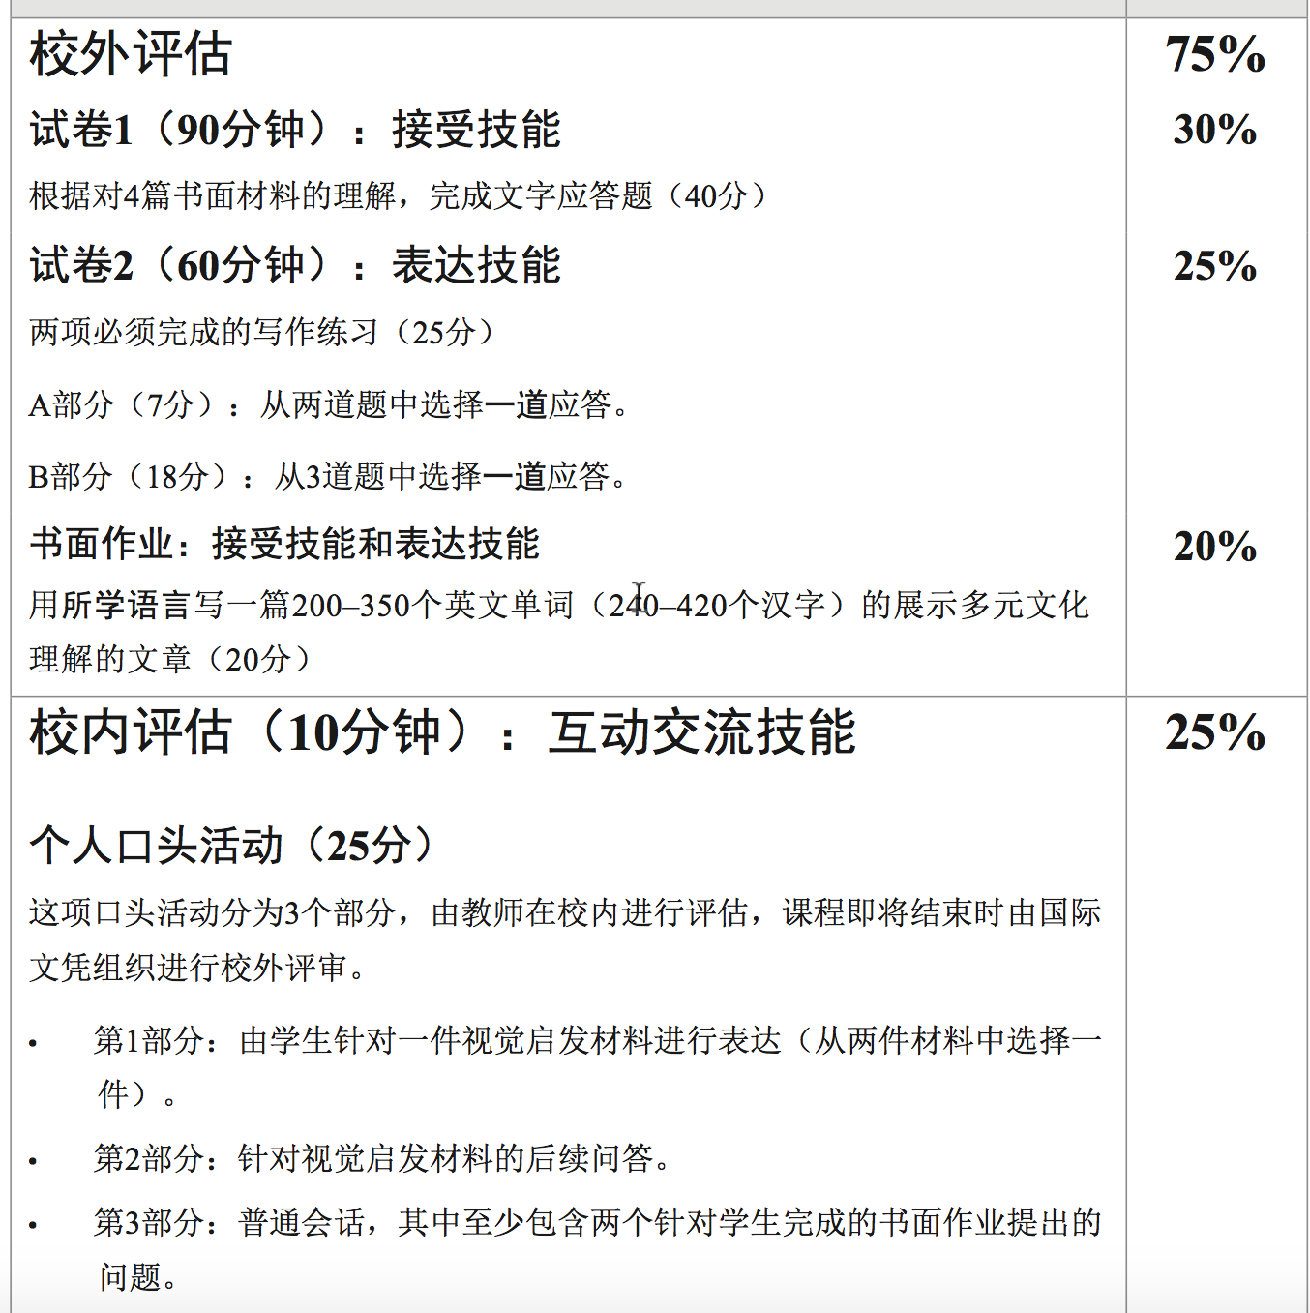

- Teaching Resources: Teacher will select appropriate materials relate to the course objectives from different resources: Authentic materials from newspapers, Chinese websites and textbooks.
- Integrated Chinese Book 1 and 2.
- Chinese Made Easy (轻松学汉语), Book 3, Book 4 & Book 5, Textbooks and Workbooks (Simplified Characters Version), 2nd Edition, by Joint Publishing (H.K.) Co., Ltd.
- Audio The text for each lesson, the listening comprehension and rhymes are on the CD(s) attached to the textbook(s)

http://mediakit.about.com/
World Languages Department Grading Policy: The World Languages Department does round up individual quarters, mid-term exams, final exam grades and end-of-course grades. Any quarter grade ending in .5 will be rounded up. Final grades for the year will be calculated based on the quality points listed above. For the final grade calculation, each quarter grade and the final exam will be worth 20% each. A final grade of 0.75 will be required in order to pass the class. Evaluation and Assessment Tests 25% Quizzes 20% Homework 10% Class participation 15% Oral presentation 30% •Please note that the Quarter exams and the final exams will worth only 20% of the grade as the same the Quiz category.
APS Grading Scale
GRADING SCALE
Letter Grade | Percentages | Quality Points | AP & IB  Quality Points
A | 90,91,92,93,94,95,96,97,98, 99, 100 | 4.0 | 5.0
B+ | 87, 88, 89 | 3.5 | 4.5
B | 80, 81, 82, 83, 84, 85, 86 | 3.0 | 4.0
C+ | 77, 78, 79 | 2.5 | 3.5
C | 70, 71, 72, 73, 74, 75, 76 | 2.0 | 3.0
D+ | 67, 68, 69 | 1.5 | 2.5
D | 60, 61, 62, 63, 64, 65, 66 | 1.0 | 2.0
E | 0 – 59 | 0.0 | 0.0
Student grades reflect student achievement and not student behavior. Quarterly grades will round up when the percentage is .5 or higher. In addition to achievement, work habits as noted in the report card comments will be evaluated for each course using the following symbols:
+ Surpasses Expectations # Meets Expectations
^ Approaching Expectations N Needs Improvement
The final grade is required to be calculated using the quality points and not percentages, letter grades, number or point systems.
Homework Policy:
Please click on this link for the Arlington Public Schools policy on homework:
http://goo.gl/FEFjPU
-Homework assignments are posted weekly on my webpage. If the student is absent it is the student’s responsibility to get missed assignments and missing quizzes when to return to the class and to check the daily homework on my webpage. -Homework, papers and projects: Will be due on the day on which the student returns to school.
-Homework will be assigned on a regular basis and be directly related to instructional objectives. -Only when homework is done completely and on time students will receive full credit for it.
-Credit will be given for timely completion of homework. -Completion of homework assignments is going to be verified by the teacher and returned to the student.
-Homework assignments are going to be clearly defined and I am going to verify student understanding of homework. -Mistakes made by the student in homework assignments are going to be corrected by the teacher.
-The amount of time required to complete the assigned tasks will vary among students. -Obtaining and completing an assignment when absent is the responsibility of the student.
Late Homework:
The students will have a chance to return the late homework the next day however the work will be graded down. The grade will be dropped one letter for each day it is late. .
Class Expectations: This class is geared towards the use of the student’s knowledge of the Chinese language. Speaking in Chinese and participating in class are requirements. Students should come to class prepared and participate during the class activities. The student is expected to participate in the following:
- Class participation: discussions, reflections, dialogues, presentations
- Completion of class work, homework, and projects
- Oral presentations: (individual and group)
- Cultural activities
Attendance: According to APS School Board Policy Implementation Procedures 25-1.1
Classroom Rules: Everyone is expected to show respect for oneself and for others as well as for school property at all times, and to obey school rules.

Academic Integrity
As a sign of respect in our school community, students will do their own work, tell the truth, respect the rights and property of others, and act honorably at all times. Incidents involving cheating, plagiarism, and/or other academic dishonesty will be taken seriously and acted upon according to the procedures set forth in the student handbook. Students will be asked to sign an honor pledge. By signing the pledge, students will acknowledge their understanding of the honor policy and that they have not violated that policy in any way.

Honor pledge: “On my honor, I pledge that I have neither given nor received information on this assignment.”

Arlington Public Schools (APS) pays for the examination fees for all IB classes. Any student who registers for an IB class, but chooses not to complete the required internal assessment and/or sit for the May examination must pay a drop fee. The International Baccalaureate Organization establishes all fees. Additionally, as outlined in the APS Program of Studies, students who do not complete the required assessments will not earn the additional quality point.

