AP EUROPEAN HISTORY: SUMMER ASSIGNMENT 2019
Introduction:
You are receiving this assignment because you signed up to take Advanced Placement European History Course during 2019-2020 school year. The summer assignment is designed to introduce you to important skills necessary for academic success in the class. In addition, the assignment introduces you to the course content (major historic developments in Europe) that will be discussed at the beginning of the upcoming school year.
If you have any questions/problems, please email me: joel.rockwood@apsva.us

Here is the link for the e-book registration:
- Connect to https://login.cengagebrain.com/course/MTPN546PRJCF
- Follow the prompts to register your MindTap course.
Important Due Dates and Information:
The entire assignment is due on your first full day of the first week of classes during the school year.
The assignment will be graded and some of our early in class assessments will be based on the summer assignment.
Purpose of Assignment:
AP European History is a fast paced, content rich class with a heavy emphasis on critical reading, writing, and thinking skills. The purpose of this assignment is to cover the content of chapter 11 of our text and to familiarize yourself to both our book and skills needed for success in class.
Estimated time to complete Assignment:
- Medici video and worksheet 60 minutes
- Map 15 minutes
- Chapter 11 terms and notes 60-90 minute
Name: _______________________________ Grade: ______
Part I
Skill: (a) Map Comprehension and
Your task: Using the Internet, textbook, or any other references, identify the following territories on the maps presented below. (Place appropriate letters on each map)

MAP 1: 14th – 15th Century Map of Europe:
- The Holy Roman Empire I. The Papal States
- France J. Russia (The Russian Principalities)
- Kingdom of Castile K. Sweden
- Kingdom of Aragon L. Kingdom of Naples
- The Ottoman Empire M. Poland
- England N. Lithuania
- Scotland O. Teutonic Knights/Prussia
- Kingdom of Navarre P. Portugal

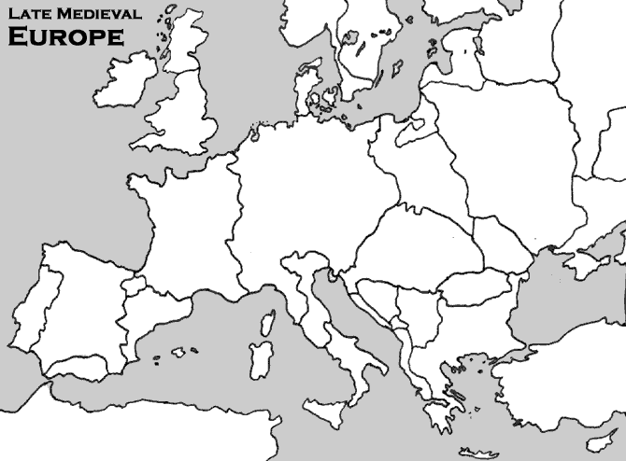
- Map 2: Italy, c.1450.
Map of Italy, c.1450 | On the map, identify:
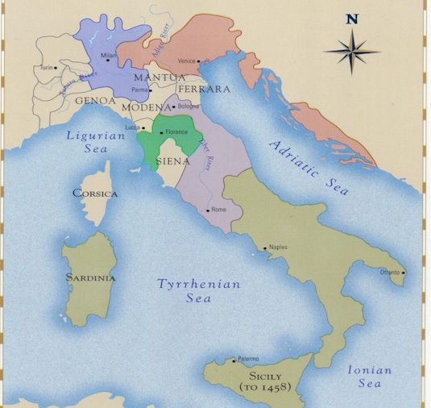 | - Dutchy of Milan  - Republic of Venice  - Papal States  - Republic of Florence  - Kingdom of Naples

Part II: Medici video and worksheet

Directions: Follow the YouTube link and fill both the viewing guide and comparison chart upon watching the movie.

Materials Needed:
• Part 1 of Medici: Godfathers of the Renaissance https://www.youtube.com/watch?v=GOAVRcI6mFU
• Viewing Guide 1 (PDF 84k) (Print page 1 and 2 on separate sheets; hand out separately to build suspense over Cosimo's fate)
• Comparison Chart: Medieval Europe and Renaissance Italy (PDF 100k)

Part III
Skill: Definition/explanation of key terms - During the course of the school year, you will be expected to define / explain a list of key terms for every chapter. Most of the key terms will be mentioned and/or described in the textbook. You will have to use outside sources for others. When addressing this part of the class, you are expected to provide a complete definition for each key term (who, what, where, when) as well as briefly explain the significance of each term.
Example:
RENAISSANCE:

Period of European history that is associated with the revival (rebirth) of interest in Greco-Roman cultures. The Renaissance first emerged and developed in the Italian city-states, such as Florence, Venice, Rome, Urbino, and Milan during 14th and 15th centuries. It represents a distinct period in European history: a break from the Middle Ages and beginning of progress for the European civilization.
Your task: Using attached pages from the textbook as well as the Internet, define the following key terms (definitions must address the terms in their historic context – 14th-15th centuries in Europe).
The Black Death –

Pogroms –

The Statute of Laborers (1351) –

The Jacquerie –

The English Peasant Revolt (led by Wat Tyler) of 1381 –

The Hundred Years’ War (major causes) –

Joan of Arc –

The Holy Roman Empire (in the 14th-15th centuries) –

Condottieri –

Unum Sanctum –

The Great (Western) Schism –

Vernacular Literature (examples from the 14th century) –

Christine de Pizan –

Humanism (during the Renaissance) –

Part IV
Skill: Note-taking – During the course of the school year, you will be, at first, required and, later, strongly encouraged, to take notes on every chapter. In fact, the best thing to do is to address all of the key terms assigned for each chapter while taking notes on each chapter. You always want to start reading with a question you want to be able to answer from the reading. Once you identify the answer write it down. This process will help you move material from your short term (desk top) memory to your long term memory (your brain’s hard drive). Note-taking will help you with the comprehension of the content as well as with the identifying areas of weakness that will need further review. There is no one particular required note-taking style for this class. Learn to learn and discover what works best for you.

A few more pointers before you begin to take notes on Chapter 11.
- You are encouraged to use symbols, abbreviations, etc. while taking notes. Try not to write in complete sentences. The only time you should write in complete sentences is when you are recording a definition of a term that is mentioned in bold or italics.
- Note-taking is not a very exciting thing to do. So, during the school year, you are encouraged to take notes in “small chunks” (in terms of time as well as in terms of pages). Every chapter in the textbook is about 30 pages (actually, it is less than 30 pages because of visuals, maps, primary sources, etc). You need to figure out the way to space out your note-taking, so that you don’t feel overwhelmed, especially if you consider your other academic and extracurricular responsibilities.
- If you are just writing down information without any purpose/method, you are wasting your time!
Now, let’s apply these methods while reading the attached pages from Ch.11 in your textbook. I will start (pp.304-308), and you will have to finish.
Ch.11: The Later Middle Ages: Crisis and Disintegration in the 14th Century
A Time of Troubles: Black Death and Social Crisis
  - Famine and Population
    - “Little Ice Age” = harvesting and weather = hunger / starvation
    - By 1300 – Population limit (support. by avail. land, tech. agriculture)
- Move from rural to urban
      - #s of Poor and Malnourished = mortality during the B.P. (black plague)
  - The Black Death – 14th century bacterial infection/epidemic disease that devastated
  - Euro. Societies
    - Originated in Asia (from China by Mongols to the Black Sea)
    - Reached Europe in 1347
      - From Sicily, Italy to the rest of Europe (France, Spain, Germany, England)
      - Followed trade routes
        - Italy – hit hard = center of Med. Trade, crowded cities.
  - Life and Death: Reactions to the Plague
    - Some “living for the moment” = wild parties
    - Rich people fled cities to their estates
    - Some became ascetics
      - Flagellants = flogged themselves w/ whips and asked for God’s forgiveness
        - Attacked Jews, anticipated end of the world, condemned by the Church
    - Rise in anti-Semitism (attacks on Jews)
      - Pogroms – organized massacres against Jews
        - Pogroms in Germany = Jews move to Eastern Europe
    - Rise in violence and preoccupation with death
  - Economic Dislocation and Social Upheaval (p.308)
(NOW IT IS YOUR TURN – Continue taking notes on the below space! Use additional paper if needed)

