Summer Assignment 2019-2020

IB Physics Year 1

Chris Cook

christopher.cook2@apsva.us

Dear prospective IB Physics Year 1 Student,

Welcome to IB Physics Year 1! The purpose of this summer assignment, adopted heavily and in some cases reported verbatim from Dr. Mark Headley’s Dealing with Uncertainties, is to help you appreciate the quality of the experimental work that you will do next year in IB Physics. This summer assignment explains the basic treatment of uncertainties as practiced in the IB physics SL curriculum, laying the foundation for what will eventually be your Internal Assessment.

Please read through the following packet, highlighting and taking notes in the margins. You should also tear off the last 2 pages entitled “Summary of Important Concepts” and use them to summarize the important points AS YOU READ WORK THROUGH THIS PACKET. Dispersed throughout the text are various problems to test your understanding of the content. Please complete these as you go. Answers can be found at this website^{[1]} so you can check your work and determine how well you are coming to understand the material.

I expect completion of this reading and the given problems to take you about than 4-6 hours over the summer. Upon returning to school, this Summer Assignment will be due the second class meeting of the school year (depending on W or L day schedules). You will then be assessed on this material in the form of a quiz (date TBD).

Hope you have a great summer and I’m looking forward to next year!

Mr. Cook
Christopher.cook2@apsva.us

^{[1]} https://sites.google.com/site/ibphysicsremediation/
Outline:
Topic | Practice Questions
Introduction | N/A
Significant Figures | 1-5
Uncertainty as a Range of Probable Values | 6-10
Measurement Uncertainty | 11-13
Statistical Uncertainty | 14-17
Uncertainty (or Error) Bars | 18-22
Absolute & Relative (or Percent) Uncertainties | 23-32
Propagating of Uncertainties:  Sum & Difference | 33-36
Propagating of Uncertainties:  Product & Quotient | 37-41
Propagating of Uncertainties:  Powers & Root | 42-45
Maximum, Minimum, and Average Best-Fits | 46-48
Random Error & Precision  Systematic Error & Accuracy | 49-55
Summary of Important Concepts | N/A

Introduction

Unless you can measure what you are speaking about
and express it in numbers, you have scarcely advanced
to the stage of science.
–Lord Kelvin

There is a basic difference between counting and measuring. My class has exactly 26 students in it, not 25.5 or 26.5. That’s counting. In contrast, a given student is never exactly 6 feet tall, nor is she 6,000 feet tall. There is always some limit of the accuracy and precision in our knowledge of any measured property – the student’s height, the time of an event, the mass of a body. Measurements always contain a degree of uncertainty. Appreciating the uncertainty in laboratory work will help demonstrate the reliability and reproducibility of the investigation, and these qualities are hallmarks of any good science.

Why do measurements always contain uncertainties? Physical quantities are never perfectly defined and so no measurement can be expressed with an infinite number of significant figures; the so-called ‘true’ value is never reached. There are also hidden uncertainties, which are part of the measurement technique itself, such as systematic or random variations. The resolution of an instrument is never infinitely fine; analogue scales need to be interpreted, and instruments themselves need calibration. All this adds to the uncertainty of measurement. We can reduce uncertainty but we cannot escape it. In order to do good science, we need to acknowledge these limits.

Significant Figures

You first become aware of uncertainties when you deal with significant figures. There may be no mention of errors or uncertainties in a given calculation, but you must still decide on the number of significant figures to quote in your final answer. Consider the calculation for circumference of a circle, where $c=2πr$ and the radius $r=4.1cm$. Enter these quantities into your calculator and press the equal key, and the solution is given as $c=25.76106cm$. What does the 0.00006 in the calculation really mean? Do we know the circumference to the 6 one hundred-thousandths of a centimeter? The 2 in $2πr$is an integer and we assume it has infinite accuracy and zero uncertainty, and π can be quoted to any degree of precision and we assume it is known accurately. But the radius is given to only two significant figures, and this represents a limit on the precision of any calculation using the value. The circumference is known, therefore, to two significant figures, and we can only say with confidence that $c≈26 cm$.

There are some general rules for determining significant figures.
(1) The leftmost non-zero digit is the most significant figure.
(2) If there is no decimal point, the rightmost non-zero digit is the least significant figure.
(3) If there is a decimal point, the rightmost digit is the least significant digit, even if it is a zero.
(4) All digits between the most significant digit and the least significant digit are significant figures. For instance, the number "12.345" has five significant figures, and "0.00321" has three significant figures. The number "100" has only one significant figure, whereas "100." has three.
Scientific notation helps clarify significant figures, so that 1.00 x 10³ has three significant figures as does 1.00 X 10⁻³, but 0.001 or 1x 10⁻³ has only one significant figure.

There is no such thing as an exact measurement, only a degree of precision. Significant figures, then, are the digits known with some reliability. Because no calculation can improve precision, we can state general rules.

First, the result of addition or subtraction should be rounded off so that it has the same number of decimal places (to the right of the decimal point) as the quantity in the calculation having the least number of decimal places. For example: 3.1cm - 0.57cm = 2.53cm $≈$ 2.5 cm.

The result of multiplication or division should be rounded off so that it has as many significant figures as the least precise quantity used in the calculation. For example:

$$11.3cm x 6.8 cm=76.85cm^{2}≈77cm^{2} \\ \frac{1}{3.01s}=0.3322259Hz≈0.332Hz$$

Practice:
- The measurement 200 cm has how many significant figures? ________________
- The measurement 206.0°C has how many significant figures? _________________
- The measurement 2.060 x 10⁻³ Coulombs has how many significant figures? ________________
- Add the following three numbers and report your answer using the correct number of significant figures (show work):
$$2.5 cm+0.50cm+0.055cm= ?$$

- Multiply the following three numbers and report your answer using the correct number of significant figures (show your work):
$$0.020cm x 50cm x 11.1cm=?$$

Uncertainty as a Range of Probable Values

To help understand the technical terms used in our treatment of uncertainties, consider an example where a length of string is measured to be 24.5 cm long, or $l=$ 24.5 cm. This best measurement is called the absolute value of the measured quantity. It is 'absolute' not because it is forever fixed but because it is the raw measured value without any appreciation of uncertainty. Next, we estimate the absolute uncertainty in the measurement, appreciating that the string is not perfectly straight, and that at both the zero and measured end of the ruler there is some interpretation of the scale. Perhaps in this case we estimate the uncertainty to be 0.2 cm; we say that the absolute uncertainty here is $∆l=$ 0.2 cm (where Δ is pronounced 'delta'). A repeated measurement or a more precise measurement of the string might reveal it to be slightly longer or slightly shorter than the initial absolute value, and so we express the uncertainty as "plus or minus the absolute uncertainty," which is written as "±". The length and its uncertainty are $l±∆l=$24.5 ± 0.2cm.

We now understand the string's length measurement by saying that there is a range of probable values. The minimum probable value is $l_{min}=$ 24.5 - 0.2cm = 24.3cm and the maximum probable value is $l_{max}=$24.5 + 0.2cm = 24.7cm.

Uncertainty is rarely needed to more than one significant figure. Therefore, we can state a guideline here. When stating experimental uncertainty to measured or calculated values, uncertainties should be rounded to one significant figure. We might say ±60 or ±0.02 but we should not say ±63.5 or ±0.015.

Also, we cannot expect our uncertainty to be more precise than the quantity itself because then our claim of uncertainty would be insignificant. Therefore there is another guideline. The last significant figure in any stated answer should be of the same order of magnitude (in the same decimal position) as the uncertainty. We might say 432± 3 or 3.06 ± 0.01 but not 432 ± 0.5 or 0.6 ± 0.02.

Practice:
- What is the range of probable values of $25.2±0.7cm$? _______________________
- What is the range of probably values of $201±10. kg?$________________________

For questions 8-10, correct the number of significant figures of the uncertainty so that the uncertainty’s precision (number of decimal places) matches the value’s precision:
- $22±0.6 N$
- $0.11±0.009\frac{m}{s}$
- $500±62 cm$

Measurement Uncertainty

Now that we understand that uncertainty expresses the range of probable values, let’s look at how we can determine the uncertainty in an experiment.

Reading analogue scales requires interpretation. For example, measuring the length of a pencil against a ruler with millimeter divisions required judgments about the nearest millimeter or fraction of a millimeter. For an analogue scale, we can usually detect the confidence to one-half the smallest division. We call one-half the smallest division the limit of the instrument. Of course, you would be making two measurements if you lined up a pencil against a ruler – a measurement for the zeroed side and a measurement at the end of the pencil. Therefore, we can say that our measurement has an uncertainty of plus or minus the smallest division.

Digital readouts are not scales but are a display of integers, such as 1234 or 0.0021. Here, no interpretation or judgment is required, but we should not assume there is no uncertainty. There is a difference between 124 and 123.4, and so digital readouts are limited in their precision by the number of digits they displace. A voltage display of 123 V could be the response to a potential difference of 122.9 V or 123.2 V, or any voltage within a range of about one volt. Although there is no interpolation with a digital readout there is still an uncertainty. The displayed value is uncertain to at least plus or minus one digit of the last significant figure (the smallest unit of measurement).

In addition to acknowledging that our instruments are not without error, we need to consider the estimations we as experimenters make when taking measurements. For example, using the above rules, a stopwatch that reads down to the millisecond would have a limit of the instrument of one-half millisecond, making for a measurement uncertainty of one-half millisecond for pushing start plus one-half millisecond for pushing stop, giving a total measurement uncertainty of one millisecond. However, it seems unreasonable to assume that a human would be precise down to one millisecond when measuring the start and stop of an event. Instead, we ought to increase our measurement uncertainty to account for the experimenter’s estimation. A human’s average reaction time is approximately 0.2s. Adding together 0.2s for pushing start and 0.2s for pushing stop, we ought to reasonable increase the measurement uncertainty to 0.4s.

Measurement uncertainty: the larger of…
(1) The limit of the instrument for each measurement taken
(2) A justified estimation of the limit of the measurement procedure as done by the experimenter

Practice:
- What is the width and measurement uncertainty on width of the object pictured below?
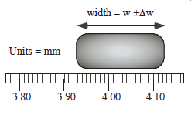
Width = _____________ $±$ ____________mm

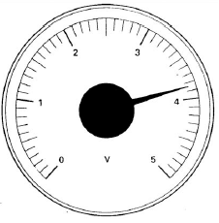
- What is the voltage and measurement uncertainty on the voltage as shown on the voltmeter below?

Voltage = ___________ $±$ ____________V

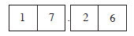
- A digital stopwatch was started at a time $t_{0}=0$ and then was used to measure ten swings of a simple pendulum to a time $t=17.26s$.
  - What is the limit of the instrument?
  - What is the smallest possible value of measurement uncertainty?
  - What is a more reasonable estimate for measurement uncertainty? Explain.

Statistical Uncertainty

In addition to quantifying an individual measurement’s uncertainty, we should take multiple measurements, or trials, as we collect data.

For example, consider a simple pendulum as it swings back and forth while five students each measure the time t for 20 compete cycle, or period T of the pendulum. The following data are recorded: $t_{1}=32.45s, t_{2}=36.21s, t_{3}=29.80,t_{4}=33.66s, t_{5}=34.08s.$To compress this data, we would take the average:

$$t_{avg}=\frac{t_{1}+t_{2}+t_{3}+t_{4}+t_{5}}{5}=\frac{\left(32.45+36..21+29.80+33.66+34.08\right)s}{5}=\frac{166.20s}{5}=33.24s$$

Although 33.24s is the point we would plot on a graph, we still need to account for the range of possible values for these five measurements. To calculate the range R, we take the difference between the largest and smallest trials. $R=t_{max}-t_{min}$. The uncertainty of the range is plus or minus one-half of the range, or $±\frac{R}{2}=±\frac{6.41s}{2}=±3.205s.$ Rounded to one significant figure for uncertainty, we get $±3s$. Ensuring that the precision of the value matches the precision of the uncertainty, we would report $33±3s.$ We call this uncertainty, calculated as one-half the range of trial values, statistical uncertainty.

Practice:
Complete the following table, calculating the average and statistical uncertainty for each row of data. (Make sure to round your uncertainty to one significant figure and make the precision of your value match!)
 | Object | Length  Trial 1 | Length  Trial 2 | Length  Trial 3 | Average Length | Statistical Uncertainty on Length
14. | Pencil | 16.1 cm | 15.6 cm | 16.6 cm
15. | Desk | 39.55 cm | 39.05 cm | 28.35 cm
16. | Human | 5.0 feet | 5.5 feet | 6.0 feet
17. | Football Field | 100.0 yards | 100.2 yards | 100.1 yards

Uncertainty (Error) Bars

Too often students will draw a graph by connecting the dots. Not only does this look bad, it keeps us from seeing the desired relationship of the graphed physical quantities. Connecting data-point to data-point is wrong. Instead, uncertainty (or error) bars ought to be used. With an uncertainty (or error) bar, the data “point” becomes a data “area”.
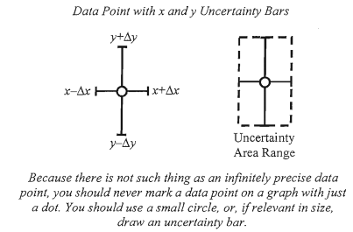

When determining the size of the uncertainty (or error) bars, we must choose the larger of the measurement uncertainty and statistical uncertainty.

For example, if the measurement uncertainty on a stopwatch is$±$0.4s (reaction time) and the statistical uncertainty for five trials is $±$0.9s, we must report uncertainty (or error) bars of $±0.9$s.

Practice:
Data is collected for an experiment where five balls of different masses were dropped in sand. The diameters of the resulting craters were measured using a meter stick. The measurement uncertainty (listed in the column header) for the diameter measurements is $±0.1m$. Determine the average diameter, statistical uncertainty on diameter, and error bars for each row.
 | Mass of Ball  (kg)  $$±0.01g$$ | Diameter of Crater  (cm)  $$±0.1cm$$
 |  | Trial 1 | Trial 2 | Trial 3 | Average | Statistical Uncertainty | Error Bars
18. | 27.92 | 8.0 | 8.0 | 8.3
19. | 46.53 | 9.3 | 9.4 | 9.0
20. | 65.37 | 9.7 | 9.5 | 10.1
21. | 105.44 | 9.9 | 10.5 | 10.4
22. | 112.01 | 10.6 | 10.6 | 10.6

Absolute and Relative (Percent) Uncertainties

While absolute uncertainties such as $10.2±0.4m$ can easily help you determine the range of probably values ($9.8m-10.6m)$, it’s hard to get a sense of just how big of a deal the uncertainty is comparison to the measurement itself. $±$0.4m might not be much in comparison to the 10.2m measurement, but $±$0.4m is quite significant if the measurement were to be 1.0m measurement.

To get sense of how large the uncertainty is in comparison the measurement value, we can convert the absolute uncertainty to relative (or percent) uncertainty.
$$relative (or percent) uncertainty=\frac{absolute uncertainty}{value}x 100$$

Looking at our example above, $10.2±0.4m$ could be re-written as $10.m ±4\%$
($rel. uncert.=\frac{0.4}{10.2}x 100=±3.92\%≈±4\%$) whereas $1.0±0.4m$ could be re-written as $1m±40\% (rel. uncert.=\frac{0.4}{1.0}x100=±40\%)$. When the absolute uncertainties are converted to relative (or percent) uncertainties, it becomes clear the $±0.4m$ is a small uncertainty (4%) when compared to the 10.2m measurement, but a large uncertainty (40%) when compared to the 1.0m measurement.

Sometimes an uncertainty is given as a relative (or percent) uncertainty, but perhaps you want to know the range of probable values. In this case you may want to convert back from relative (or percent) uncertainty to absolute uncertainty.

$$absolute uncertainty=\frac{relative \left(or percent\right) uncertainty}{100}x value$$
To keep track of absolute and relative (or percent uncertainties), we use the following notation:

Absolute Uncertainty  $$x±∆x$$  Ex. $10.2±0.5cm$ | Relative (or percent) uncertainty  $$x±\left(\frac{∆x}{x}\right)$$  Ex. $10.±5\%$

Practice:
For questions 23-32, complete the following table:
 | Given | Is the given a…  Absolute or Relative (Percent)  Uncertainty? | Convert to the opposite form  (show work)  (Careful with precision!)
23. | $$5.2±0.1g$$
24 | $$22lbs±5\%$$
25 | $$4cm±3\%$$
26 | $$2.40±0.02g$$
27 | $$112mg±2\%$$
28 | $$5.0x{10}^{-2}±0.01g$$
29 | $$7cm±10\%$$
30 | $$3x{10}^{3}kg±20\%$$
31 | $$2.92±0.01cm$$
32 | $$301±10kg$$

Propagating Uncertainties: Sum and Difference

At times, the desired physical quantity in an experiment may not be as simple as measuring that quantity directly; we may need to make some calculations. For example, if one of our variables is the perimeter of a rectangular plate, we would measure the length and width, but then need to perform a separate calculation to determine the perimeter. While length and width would have measurement uncertainties and statistical uncertainties attached to them, these uncertainties need to be carried through, or propagated through, the calculation. We will now examine various rules surrounding uncertainty propagation.
Let us say you want to make some calculation of a rectangular metal plate. The length L is measured to be 36mm with an estimated uncertainty of $±3mm$, and the width W is measured to be 18mm with an estimated uncertainty of $±1mm$. How precise will your calculation of perimeter be when you take into account the uncertainties?

We assume the parallel lengths and the parallel widths are identical, where $L=36±3mm$ and $W=18±1mm$. The perimeter is the sum of the four sides.

$$P=L+W+L+W=36mm+18mm+36mm+18mm=108mm$$

To find the least probably perimeter, you subtract the uncertainty for each measurement and then add the four sides. The minimum lengths and widths would be $L_{min}=36-3mm=33mm$and $W_{min}=18-1mm=17mm.$ The minimum probably perimeter is $P_{min}=L_{min}+{W_{min}+L}_{min}{+W}_{min}=100mm.$

To find the maximum probably perimeter, you add the uncertainty to each length and width, and then you add the four sides together where $L_{max}=36+3mm=39mm$ and $W_{max}=18+1mm=19mm.$ $P_{max}=L_{max}+W_{max}+L_{max}+W_{max}=116mm.$

The range from maximum to minimum is the difference of these two values:

$$P_{range}=P_{max}-P_{min}=116mm-100mm=16mm.$$

The range includes both the added and subtracted uncertainty values. The absolute value lies midways, so we divide the range in half to find the uncertainty in the perimeter, $∆P$.

$$∆P=\frac{P_{range}}{2}=\frac{16mm}{2}=8mm$$

This is correctly expressed as $∆P=8mm$, and the perimeter and its absolute uncertainty is written as:

$$P±∆P=108±8mm$$

We can generalize this process. When we add quantities, we add their uncertainties.

What about subtracting quantities? Subtraction is the same as addition except we add a negative quantity, $A+B=A-(-B)$. And the uncertainties? It would make no sense to subtract uncertainties because this would reduce the resultant value; we might even end up with zero uncertainty. Hence we add the uncertainties just as before. There is a general rule for combining uncertainties with sum and differences. Whenever we add or subtract quantities, we add their absolute uncertainties. This is symbolized as follows:
Sum: $\left(A±∆A\right)+\left(B±∆B\right)=(A+B)±(∆A+∆B)$
When adding values, add their absolute uncertainties

Difference: $\left(A±∆A\right)-\left(B±∆B\right)=(A-B)±(∆A+∆B)$
When subtracting values, add their absolute uncertainties

Practice:
For questions 33-36, add or subtract the given values, expressing your answer with the correct, propagated uncertainty.
- Add $4±1m$ and $12±2m$.
- Express your answer using absolute uncertainty.
- Convert your answer to relative uncertainty.

- Subtract $4±1m$ from $12±2m$.
- Express your answer using absolute uncertainty.
- Convert your answer to relative uncertainty.

- If $m_{1}=100.0±0.4g$ and $m_{2}=49.3±0.3g$. What is their sum, $m_{1}+m_{2}?$
- Express your answer using absolute uncertainty.
- Convert your answer to relative uncertainty.
- If $m_{1}=100.0±0.4g$ and $m_{2}=49.3±0.3g$. What is the difference, $m_{1}-m_{2}?$
- Express your answer using absolute uncertainty.
- Convert your answer to relative uncertainty.

Propagating Uncertainties: Product & Quotient

Let’s return to our example of a rectangular metal plate of length $L=36±3mm$ and width $W=18±1mm$. Next we calculate the area of the metal plate. The area is the product of length and width.

$$A_{absolute}=L_{absolute} x W_{absolute}$$

The minimum probable area is the product of the minimum length and minimum width.

$$A_{min}=L_{min} x{ W}_{min}=33mm x 17mm=561mm^{2}$$

The maximum probable are is the product of the maximum length and maximum width.

$$A_{max}=L_{max} x W_{max}=39mm x 19mm=741mm^{2}$$

The range of values is the difference between the maximum and minimum areas.

$$A_{range}=A_{max}-A_{min}=741mm^{2}-651mm^{2}=180mm^{2}$$

This range is the result of both adding and subtracting uncertainties to the lengths and widths, and the absolute value is midway between these extreme values. Therefore, the uncertainty ΔA in the area is just half the range; it is added to and subtracted from the absolute area in order to find the probable limits of the area.

$$∆A=\frac{A_{range}}{2}=\frac{180mm^{2}}{2}=90mm^{2}$$

We can now express the area and its uncertainty to significant figures:

$$A±∆A=648mm^{2}±90mm^{2}≈650±90mm^{2}$$

To further develop the handling of uncertainties, let us now calculate the relative (or percent) uncertainties in both the absolute length and absolute width measurements.

$$∆L\%=\frac{ΔL}{L}100\%=\frac{33m}{36mm}100\%=8.33\% \\ ∆W\%=\frac{ΔW}{W}100\%=\frac{1mm}{18mm}100\%=5.55\%$$

Adding these two percentage gives us $8.33\%+5.55\%=13.88\%$. It is no coincidence when taking this percentage of the area $\left(\frac{90}{100}x 650=13.84\%\right)$ that we get the same value of uncertainty we got when calculated the extreme values.

The calculated area is now $A±∆A=648±89.9424mm^{2}≈650±90mm^{2}$. Expressed as a relative (or percent) uncertainty, the area is written as $A±∆A\%=648mm^{2}±13.88\%≈650mm^{2}±14\%.$

The only apparent difference between finding the extreme values and using relative (or percent) uncertainties is that using percentage is easier; it requires fewer calculations. Moreover, using percentage will simplify our work when dealing with complex equations involving variation of product and quotient, including square roots, cubes, etc. (in the next section). Although some examples may show a slight difference between the calculation of extremes and the use of percentages, most of the difference is lost when rounding off the correct number of significant figures. However, when making higher-level calculation (such as cubes and square roots), any slight difference between the two methods may become noticeable and the use of percentages will yield a smaller uncertainty range. This, of course, is desirable.

When multiplying quantities, we add the relative (or percent) uncertainties to find the uncertainty in the product. Dividing two quantities is the same an multiplying one by the reciprocal of the other, such that $\frac{A}{B}=A\left(\frac{1}{B}\right)$. This means we should add the relative (or percent) uncertainties when we divide. You might be tempted to subtract percentages of uncertainties when dividing but then you would be reducing the effective uncertainty and you might end up with zero or even negative uncertainty. This is not acceptable. Therefore, the rule of product and for quotients is one and the same. We add the relative (or percent) uncertainties when we find the product or quotient of two or more quantities. This rule is symbolized as follows.

Product $\left(A±∆A\right) x \left(B±∆B\right)=\left(A x B\right)±\left[\left(\frac{∆A}{A}100\right)\%+\left(\frac{∆B}{B}100\right)\%\right]$
When multiplying values, add the relative uncertainties.

Quotient $\frac{A±∆A}{B±∆B}=\frac{A}{B}±\left[\left(\frac{∆A}{A}100\right)\%+\left(\frac{∆B}{B}100\right)\%\right]$
When dividing values, add the relative uncertainties.

For example, find z where $z=\frac{x}{y}$ and $x±∆x=22±1$ and $y±∆y=431±9$.

$$z±∆z=\frac{x±∆x}{y±∆y}=\frac{22±1}{431±9}=\frac{22}{431}±\left[\left(\frac{1}{22}100\right)\%+\left(\frac{9}{431}100\right)\%\right] \\ z±∆z=\frac{22}{431}±\left(4.545\%+2.089\%\right)=0.05104±6.633\% \\ z±∆z=0.05105±0.00338≈0.051±0.003$$

Practice:
For questions 37-41, multiply or divide the given values, expressing your answer with the correct, propagated uncertainty.
- Multiply $4±1m$ by $12±2m$.
- Express your answer using relative uncertainty.
- Convert your answer to absolute uncertainty.

- Divide $4±1m$ by $12±2m$.
- Express your answer using relative uncertainty.
- Convert your answer to absolute uncertainty.

- Calculate the density ($density=mass/volume$) of a block of mass $m=245±2g$ and with sides of $2.5±0.1cm, 4.8±0.1cm, and 10.2±0.1cm$.
a. Express your answer using relative uncertainty.
b. Convert your answer to absolute uncertainty.

- An electrical resistor has a 2% tolerance and is marked R=1800 Ω. An electrical current of $I=2.1±0.1$ mA (mA = milliamps, or 10⁻³ amps) flows through the resistor. What is the voltage (V=IR)?
a. Express your answer using relative uncertainty.
b. Convert your answer to absolute uncertainty.

- The frequency of a wave is given as $f=0.7±0.1 Hz$. What is the period T (where T=1/f)?
a. Express your answer using relative uncertainty.
b. Convert your answer to absolute uncertainty.

Propagating Uncertainties: Powers & Roots

Squaring a number is the same as multiplying it by itself, $A^{2}=A x A$. With uncertainties, we have ${\left(A±∆A\right)}^{2}=(A±∆A)(A±∆A)$. Where the uncertainty A is expressed as a percentage, we can see that this percentage is added to itself to find the percentage of uncertainty in $A^{2}$.

$${\left(A±∆A\%\right)}^{2}=\left(A±∆A\%\right)\left(A±∆A\%\right)=A^{2}±2∆A\%$$

Similarly, taking the square root of a number is the same as taking the number to a power of one-half, $\sqrt{x}=x^{\frac{1}{2}}$, where, for instance, $\sqrt{36}={36}^{\frac{1}{2}}=6$.

We have to be cautious here. Previously, mathematical operations increased the overall uncertainty. But taking the square root of a number yields a much smaller number, and we would not expect the uncertainty to increase to a value greater that the square root itself. Also, our combination of uncertainties must be consistent in a way that when we reverse the process we end up with the same number and with the same uncertainty we started with. For instance, $\sqrt[3]{x^{3}}$must equal x, and the same with the uncertainties. Therefore it seems fair to say that taking x to the one-half power will cut the uncertainty in half. Then, when you square the square root and propagate the uncertainties, you end up with the original uncertainty the original absolute value.

The rules for any $n^{th}$ power or $n^{th}$ root is symbolized as follows:

$n^{th}$ Power ${\left(A±∆A\right)}^{n}=A^{n}±n\left(\frac{∆A}{A}100\%\right)=A^{n}±n∆A\%$
When raising a value to the $n^{th}$power, multiply the relative (or percent) uncertainty by the power n.

$n^{th} root$ $\sqrt[n]{A±∆A}={\left(A±∆A\right)}^{\frac{1}{n}}=A^{\frac{1}{n}}±\frac{1}{n}\left(\frac{∆A}{A}100\%\right)$
When taking the $n^{th}$root of a value, multiple the relative (or percent)
uncertainty by $\frac{1}{n}$
Practice:
For questions 42-45, perform the necessary mathematical function for the given values, expressing your answer with the correct, propagated uncertainty.

- Square $4.0±0.2s.$
a. Express your answer using relative uncertainty.
b. Convert your answer to absolute uncertainty.

- Calculate the area of a circle whose radius is determined to be $r=14.6±0.5cm$.
a. Express your answer using relative uncertainty.
b. Convert your answer to absolute uncertainty.

- Einstein’s famous equation relates energy and mass with the square of the speed of light, where $E=mc^{2}$. What is the energy for a mass of $m=1.00±0.05kg$ where the speed of light is $c=3.00x{10}^{8}±0.02x{10}^{8} m/s$?
a. Express your answer using relative uncertainty.
b. Convert your answer to absolute uncertainty.

- A square piece of paper has an area of $4.1±0.1 cm^{2}$. What is the length of one side?
a. Express your answer using relative uncertainty.
b. Convert your answer to absolute uncertainty.

Maximum, Minimum, and Average Best-Fits

Once the values and uncertainty (or error) bars have been plotted on graph, we can begin to look to patterns. Perhaps our data shows a linear pattern, or a flat line pattern, or quadratic pattern, or an inverse pattern, or an inverse square pattern, or some other, more complex pattern. A graph helps us visualize what patterns might exist in our data.

To express a potential pattern in mathematical terms, we draw maximum and minimum best-fits through the error bars. The maximum best-fit is a line with the maximum (steepest) possible slope while still passing through nearly all uncertainty (or error) bars. The minimum best-fit is a line with the minimum (shallowest) possible slope while still passing through nearly all uncertainty (or error) bars.
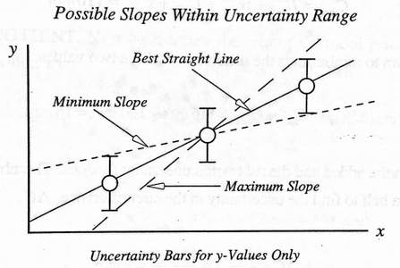

Consider the following graph:
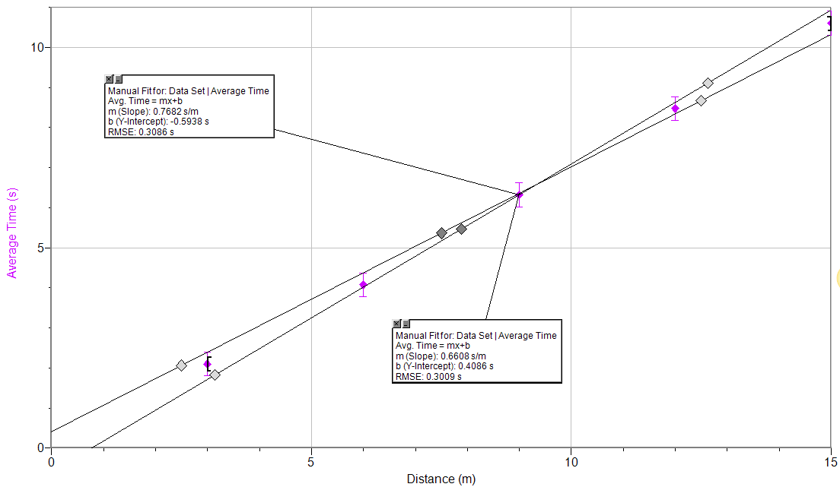
On this graph, there are two best-fits. Notice how each best-fit has been adjusted to go through nearly all the error bars. The steeper line (slope of 0.7682 s/m) is the maximum best-fit and the shallower line (slope of 0.6608 s/m) is the minimum best-fit.
To report the maximum and minimum best-fits, we use the following form:

y (y units) = (slope & slope units) x (x units) + y-int. & y-int. units

For example, the maximum and minimum best-fits for the graph above would be reported as:

$$Maxmimum: T\left(s\right)=\left(0.7682\frac{s}{m}\right) D\left(m\right)-0.5938s \\ Minimum: T\left(s\right)=\left(0.6608\frac{s}{m}\right) D\left(m\right)+0.4086s$$
Notice how the units on the right side of the equal sign reduce to seconds, just as on the left side of the equal sign.

Finally, we combine the maximum and minimum best-fits to report just one, average best-fit for the data. This average best-fit is essentially a mathematical expression of the apparent pattern that exists in the data. The average best-fit is reported in the following form:

y (y units) = (Avg. slope $±$ slope uncert. & slope units) x (x units) + (Avg. y-int. $±$ y-int. uncert. & y-int. units)

$$Avg. slope=average of maximum and minimum slopes=\frac{1}{2}\left(m_{max}+m_{min}\right) \\ Slope Uncert. =half the range of maximum and minimum slope=\frac{1}{2}\left(m_{max}-m_{min}\right) \\ Avg. y-int. =average of maximum and minimum y-intercepts=\frac{1}{2}\left(b_{max}+b_{min}\right) \\ Y-int. Uncert.=half the range of maximum and minimum y-int.= \frac{1}{2}(b_{max}-b_{min})$$

For our example in the graph above, we could make the following calculations:

$$avg. slope=\frac{1}{2}\left(0.7682+0.6608\right)=0.7145=0.71 \left(to match uncertainty^{'}s precision below\right) \\ slope uncert. =\frac{1}{2}\left(0.7682-0.6608\right)=0.0537=0.05 \left(with one sig. fig.\right) \\ avg. y-int. =\frac{1}{2}\left(-0.5938+0.4086\right)=-0.0926=0.1 \left(to match uncertianty^{'}sprecision below\right) \\ y-int. uncert. =\frac{1}{2}\left(0.4086-\left(-0.5938\right)\right)=0.5012=0.5 (with one sig fig)$$

Making our average best-fit equation:
$$T\left(s\right)=\left(0.71±0.05\frac{s}{m}\right)D\left(m\right)+\left(0.1±0.5s\right)$$

Notice again how the units on the right side of the equal sign reduce to seconds, just as on the left side of the equal sign.

Practice:
- Draw and clearly label in the maximum and minimum best-fits on the graph below.
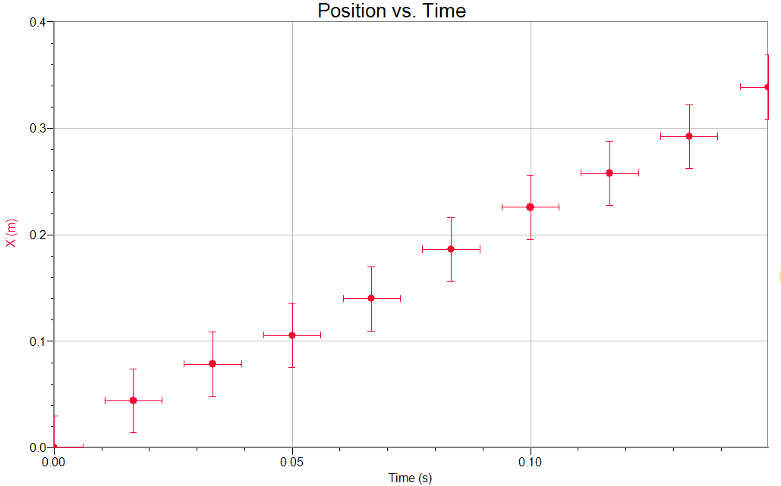

- Given the maximum and minimum best-fit equations listed below, write the average best fit equation in its correct form.
$$maximum: F\left(N\right)=\left(6.3298\frac{N}{kg}\right)m\left(kg\right)+0.4782N \\ minimum: F\left(N\right)=\left(3.2753\frac{N}{kg}\right)m\left(kg\right)+1.2933N$$
- Given the maximum and minimum best-fit equations listed below, write the average best fit equation in its correct form.
$$maximum: v\left(\frac{m}{s}\right)=\left(9.8273\frac{m}{s^{2}}\right)t\left(s\right)-0.7228\frac{m}{s} \\ minimum: v\left(\frac{m}{s}\right)=\left(7.2897\frac{m}{s^{2}}\right)t\left(s\right)+0.4420\frac{m}{s}$$

Random Error & Precision; Systematic Error & Accuracy

Once the average equation of best-fit has been written, we can begin to analyze the results.

Examining the spread in data, we can make claims about the reproducibility of the results. If the uncertainty (or error) bars were extremely large, our data was not very reproducible; it varied greatly from one measurement to the next. We would say there is a large random error and that the data was thus not very precise. In contrast, if the uncertainty (or error) bars were very small, our data would be reproducible; it did not vary greatly from one measurement to the next. We would say there is small random error and thus the data was very precise.

To quantify random error and thusly support our claims about precision, we consider two factors:
- Outliers: were there any outliers in the data that you excluded from your best-fits?
- Slope Uncertainty: to get a sense of the spread in data, we convert the slope uncertainty in our average best-fit equation to a relative (or percent) uncertainty. A slope uncertainty <2% indicates a minimal spread in data, a slope uncertainty >2% and <5% indicates a medium spread in a data, and a slope uncertainty >10% indicates a very large spread in data.
It’s the combination of these two factors that helps us to determine the amount of random error (low, medium or high) and therefore make a claim about the precision of our data (high, medium or low).

The systematic error and therefore the accuracy of a measurement is its relation to the true, nominal, or accepted value. As you begin to design experiments, you will see that different variables (slope, y-intercept, area under the curve, etc.) have physical meanings that can be compared to accepted values. Perhaps you compare your slope to the freefall constant 9.81 m/s², or perhaps your y-intercept on a distance-time graph is expected to be zero indicating no starting distance. It takes research and a little physics creativity to look for the meaning in graphs, but doing so allows you to comment on the systematic error and therefore make claims of accuracy. If an experiment yields a result extremely close to the accepted value, we’d say there is little systematic error and therefore high accuracy; If an experiment yields a result very off from the accepted value, we’d say there is a lot of systematic error and therefore low accuracy.

To quantify systematic error and thusly support our claims about accuracy, we work through the following thought process:
- Determine what has meaning in your graph – check slope, y-intercept, and area under the curve.
- Research the accepted value.
- Compare the experimental value (with a range of probable values according to its uncertainty) to the accepted value. If the accepted value falls within the experimental value’s probable range of values, there is no systematic error (high accuracy). If the accepted values does not fall within the experimental value’s probable range of values, there is systematic error (low accuracy.)

In physics, we seek both precision and accuracy. Alan Greenspan, the U.S. Federal Reserve Chairman, has commented: “It is better to be roughly right than precisely wrong.”

Consider a hunter shooting ducks. Don’t worry; the ducks are plastic. The four figured sketched below represent combinations of precision and accuracy.

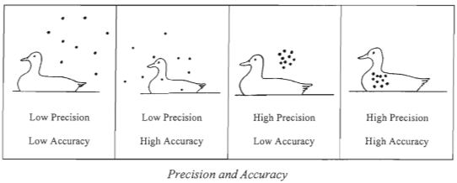

We can conclude that an accurate shot means we are close to (and hit) the target but the uncertainty could be of any magnitude, large or small. To be precise, however, means there is a small uncertainty, but this does not mean that we hit the target. To be both accurate and precise means we hit the target often and have only a small uncertainty.

Practice:
- A measurement that closely agrees with accepted values is said to be _____________________.
Use the following picture to answer questions 50-53:
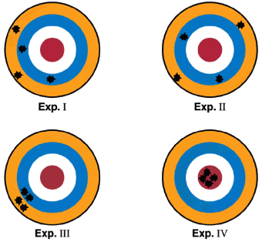
- Which experiment is precise but not accurate? ____________________
- Which experiment is accurate but not precise? ____________________
- Which experiment is precise AND accurate? _______________________
- Which experiment is neither precise nor accurate? __________________
- An experiment is performed such that the slope of the graph is determined to be the freefall constant. The accepted value for the freefall constant is 9.81 m/s². Your slope value is $9.77±0.05 m/s^{2}$. Make a claim about the experiment’s systematic error and accuracy.

- An experiment is performed such that the equation of average best-fit is
$x\left(m\right)=\left(5.4±0.1\frac{m}{s}\right)t\left(s\right)+\left(0.9±0.1s\right)$. There were no outliers in the graph. Make a claim about the experiment’s random error and precision.

Summary of Important Concepts:

Please fill out this summary of important concepts according to the reading and examples.

Significant figure rules:
(1)

(2)

(3)

(4)

Measurement Uncertainty:
- The limit of the instrument is calculated by taking half of the _________________________________________.
- The measurement uncertainty is the larger of the limit of the instrument and _________________________________________.
- Measurement uncertainty is written in a data table’s __________________________________________.

Statistical Uncertainty:
- Statistical uncertainty is calculated by taking half of the ___________________________________.

Uncertainty (or Error) Bars:
- Error bars are the larger of _________________________ and ______________________________.

Absolute vs. Relative (or Percent) Uncertainty:

$$relative \left(or percent\right) uncertainty=\frac{absolute uncertainty}{value}x 100 \\ absolute uncertainty=\frac{relative \left(or percent\right) uncertainty }{100}x value$$

Propagation rules:
- When adding or subtracting values, propagate uncertainty by _______________________________
_________________________________________________________________________________.
- When multiplying or dividing values, propagate uncertainty by ______________________________
_________________________________________________________________________________.
- When raising a value to some power, propagate uncertainty by ______________________________
_________________________________________________________________________________.
- When rooting a value, propagate uncertainty by _________________________________________
_________________________________________________________________________________.

Maximum, Minimum, and Average Best Fits:
- The maximum best-fit has the ____steepest/shallowest______ slope whereas the minimum best-fit has the ____steepest/shallowest_____ slope.
- The general form of a maximum or minimum best-fit is:
- The general form of an average best-fit is:
- The average slope is calculated by __________________________________________________.
- The average slope’s uncertainty is calculated by _______________________________________.
- The average y-intercept is calculated by _____________________________________________.
- The average y-intercept’s uncertainty is calculated by __________________________________.

Random Error, Precision, Systematic Error, Accuracy:
- The type of error that captures the reproducibility of the data is _________________________.
- The type of error associated with how close the data got to the accepted value is ____________
______________________.
- If an experiment has low random error it is highly _____precise/accurate______.
- If an experiment has low systematic error it is highly _____precise/accurate______.
- The factors that determine random error include:
(1)

(2)

- The factors that determine systematic error include:
(1)

(2)

(3)

